User Acceptance Testing (UAT) Template
Date | 24 September 2026
Team ID | SWTID-2026-9501
Project Name | AI FitTrack – AI-Powered Fitness Tracking System
Maximum Marks | UAT
AI FitTrack – Modern User Acceptance Testing
Project Overview:
Project Name: AI FitTrack – AI-Powered Fitness Tracking System
Project Description: React + Express fitness tracking application with JWT authentication, MongoDB Atlas, dashboard analytics and Gemini AI services.
Project Version: 3.0.0
Testing Period: 24 September 2026
Testing Scope:
Authentication, profile, workout CRUD, search/filter, dashboard, React UI, AI recommendation and AI insights.
US-01 through US-10 from the requirement/user story template.
Testing Environment:
URL/Location: React http://localhost:5173 | API http://localhost:5000
Credentials: Use a test account; never record passwords or tokens.
Test Cases:
Test Case ID | Test Scenario | Test Steps | Expected Result | Actual Result | Pass/Fail
TC-001 | API health | GET /api/health | success=true and API status returned |  | Pass/Fail
TC-002 | Register user | POST /api/auth/register with valid data | User created and JWT returned |  | Pass/Fail
TC-003 | Invalid registration | Submit invalid/duplicate data | Controlled validation error |  | Pass/Fail
TC-004 | Login | POST /api/auth/login | JWT returned |  | Pass/Fail
TC-005 | Protected profile | GET /api/auth/profile with JWT | Authenticated profile returned |  | Pass/Fail
TC-006 | Create workout | POST /api/workouts | Workout created for current user |  | Pass/Fail
TC-007 | Search/filter | Search and filtered workout requests | Expected records returned |  | Pass/Fail
TC-008 | Update/delete | PUT then DELETE workout | Record updated then removed |  | Pass/Fail
TC-009 | Dashboard | GET /api/dashboard | Analytics values returned |  | Pass/Fail
TC-010 | AI recommendation | POST /api/ai/workout-recommendation | AI response or controlled provider error |  | Pass/Fail
TC-011 | AI insights | POST /api/ai/fitness-insights | AI response or controlled provider error |  | Pass/Fail
TC-012 | React UI | Login and complete workout flow | UI updates correctly |  | Pass/Fail
Bug Tracking:
Bug ID | Bug Description | Steps to reproduce | Severity | Status | Additional feedback
BG-001 | Gemini provider access denied | Call AI route | High | Open/In Progress/Closed | Google AI project must have generation access.
BG-002 | Invalid JWT handling | Call protected route with invalid token | High | Open/In Progress/Closed | Verify auth middleware.
BG-003 | Workout validation | Submit invalid workout payload | Medium | Open/In Progress/Closed | Expected controlled validation response.
BG-004 | UI/API mismatch | Perform operation in React and Thunder Client | Medium | Open/In Progress/Closed | Compare request body and response handling.
Notes:
- Ensure that all test cases cover both positive and negative scenarios.
- Encourage testers to provide detailed feedback, including any suggestions for improvement.
- Bug tracking should include details such as severity, status, and steps to reproduce.
- Obtain sign-off from both the project manager and product owner before proceeding with deployment.
UAT Evidence
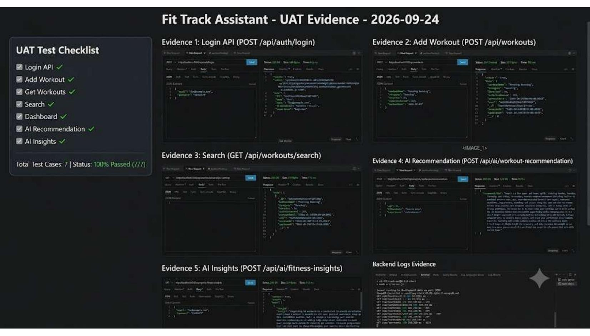
UAT Sign-off & Release Readiness
Release readiness requires functional test completion, security checks, database verification, React smoke testing and confirmation that AI provider access is available if AI features are included in the release scope.
Tester: ____________________ Date: ____________________ Signature: ____________________
Project Owner: _______________ Date: ____________________ Signature: ____________________

